

课程名称： Python程序设计 课程代码： CW2006
任课老师： 赵稳 实验指导老师: 赵稳

设计性实验报告名称： 疫情信息管理系统

学生姓名： 杨艾琳
学号： 2040706101
教学班： BNX
递交日期： 2022.06.09
签收人：

我申明，本报告内的实验已按要求完成，报告完全是由我个人完成，并没有抄袭行为。我已经保留了这份实验报告的副本。

申明人(签名):

实验报告评语与评分：

评阅老师签名：

设计性实验：XXX应用系统
实验学时：6学时
涉及的知识点：Python数据结构(列表、元组、字典、文件等)、网络爬虫与信息提取、图形界面、事件处理、中文分词与统计、图形图像处理、Numpy、Matplotlib等
一、实验目的
针对某一方面或领域，使用Python语言设计、实现一个应用系统，要求学生熟悉python的基本概念、基础知识和基本应用，熟悉Python常用库的安装与使用，涉及的知识点可以包括：常用的数据结构、网络爬虫与信息提取、图形界面、事件处理、中文分词与统计、图形图像处理、Numpy、Matplotlib等，培养学生程序设计能力，增强项目实践经验。
二、实验要求
要求1人单独完成项目设计，不得抄袭，编写一个“XXX应用系统”。提交实验报告、源程序(.py文件)、程序运行截图。
三、考核形式
课程设计分数将占课程总评成绩的10%，评分原则：(用百分比表示)
(1)所使用的知识点，占40%，包括常用的数据结构、网络爬虫与信息提取、中文分词与统计、图形图像处理、Numpy、Matplotlib等多个知识点的综合应用(至少两项);
(2)有图形界面，能够进行事件处理，界面尽可能美观、大方、易用，占25%；
(3)功能实现程度，要求功能多样、实用，程序代码不少200行，占25%；
(4)设计报告10%。
特别提示：(1)功能独特、创意新颖者，给予1-10%加分；(2)抄袭者得0分。
四、实验报告要求
实验报告除必须的实验目的、实验要求之外，必须具备以下内容：
（1）程序已经实现的功能点（用100-200字进行说明）；
本程序使用pyqt进行窗体设计。实现了连接数据库实现用户登录，页面跳转，将数据库内容呈现在窗体中。运用爬虫技术，爬取全国疫情实时数据，进行数据处理。使用Matplotlib将处理过的数据以图表的形式呈现到窗体。实现了输入不同省市名称，呈现不同省市数据。实现了生成疫情省市词云功能。

（2）程序运行截图及说明（每图限50到100字）；
登录界面，此处连接数据库，验证输入的账号密码是否存在数据库中。
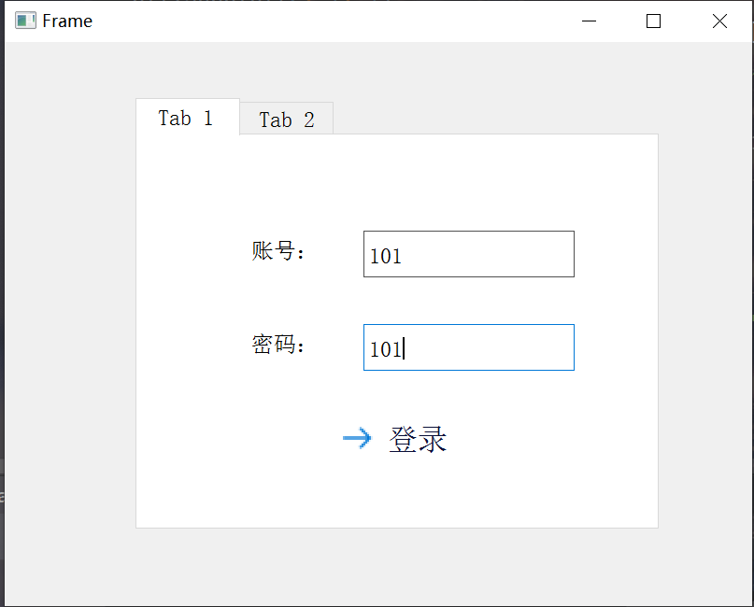

登录成功，进入主页面。
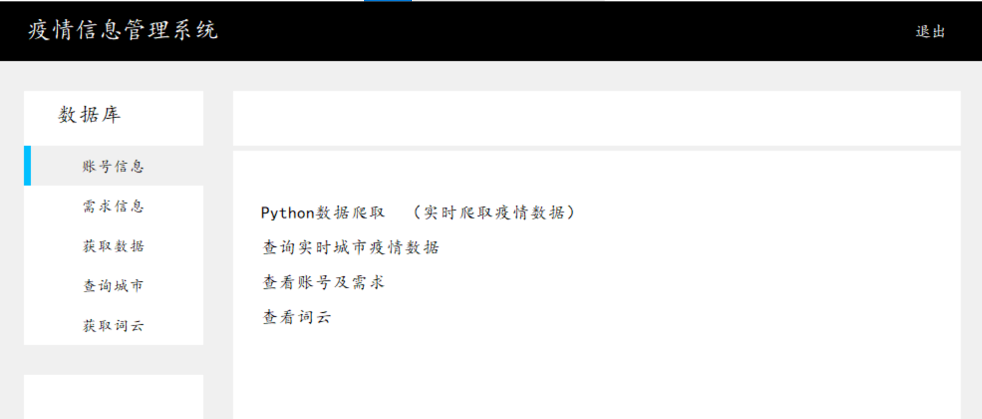
点击账号信息，获取数据库中存在的账号信息：
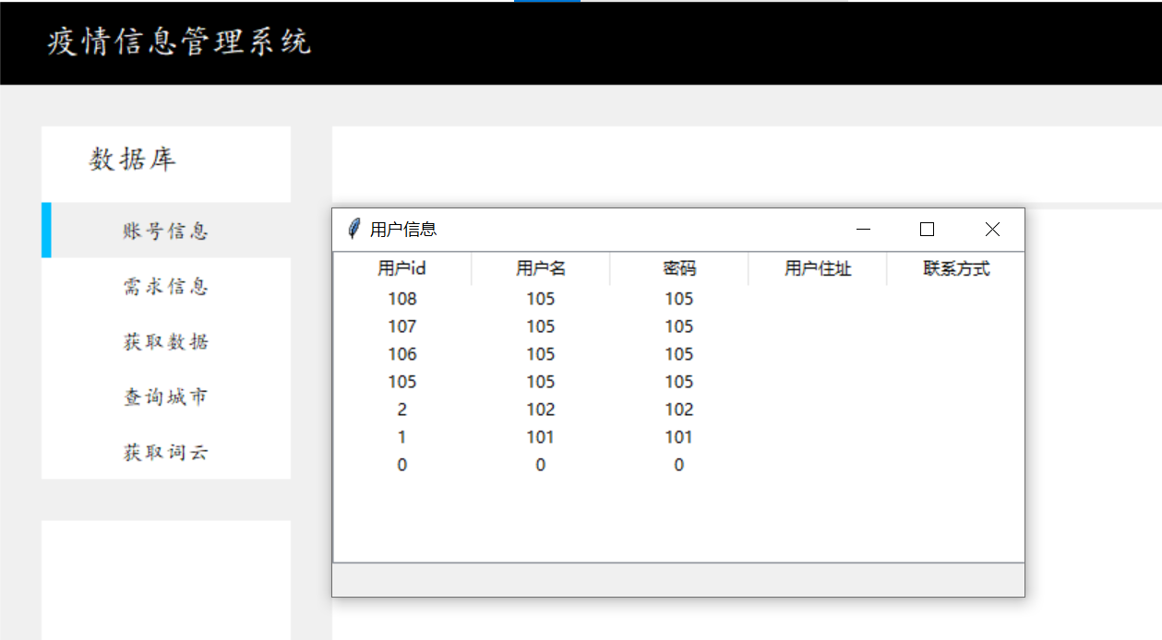
点击获取数据，爬取腾讯新闻的实时疫情数据，若爬取成功则显示弹窗，将数据存到根目录下，存储格式为xlsx：
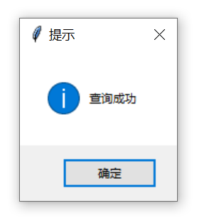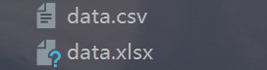
点击查询城市，弹出查询城市窗体：
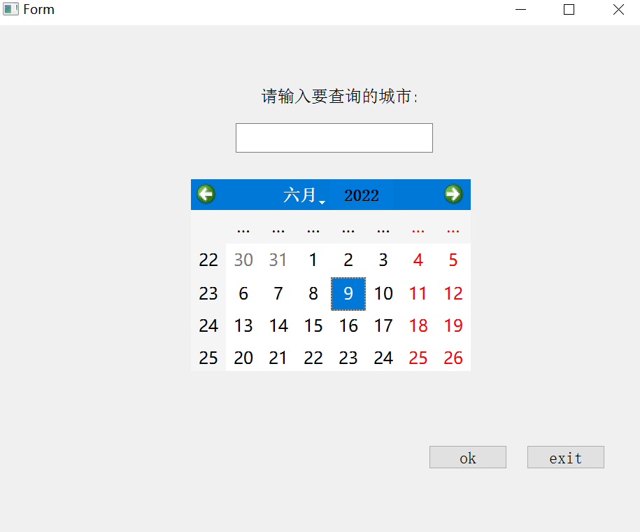
Citydata实现输入要查询省市的名称（此处必须输入省、直辖市、特别行政区名称，不可输入“广州”）
如图，输入“台湾”，显示当日台湾疫情数据
malt.py将data.xlsx转换为data.csv文件，并将数据以图表形式呈现到页面中。
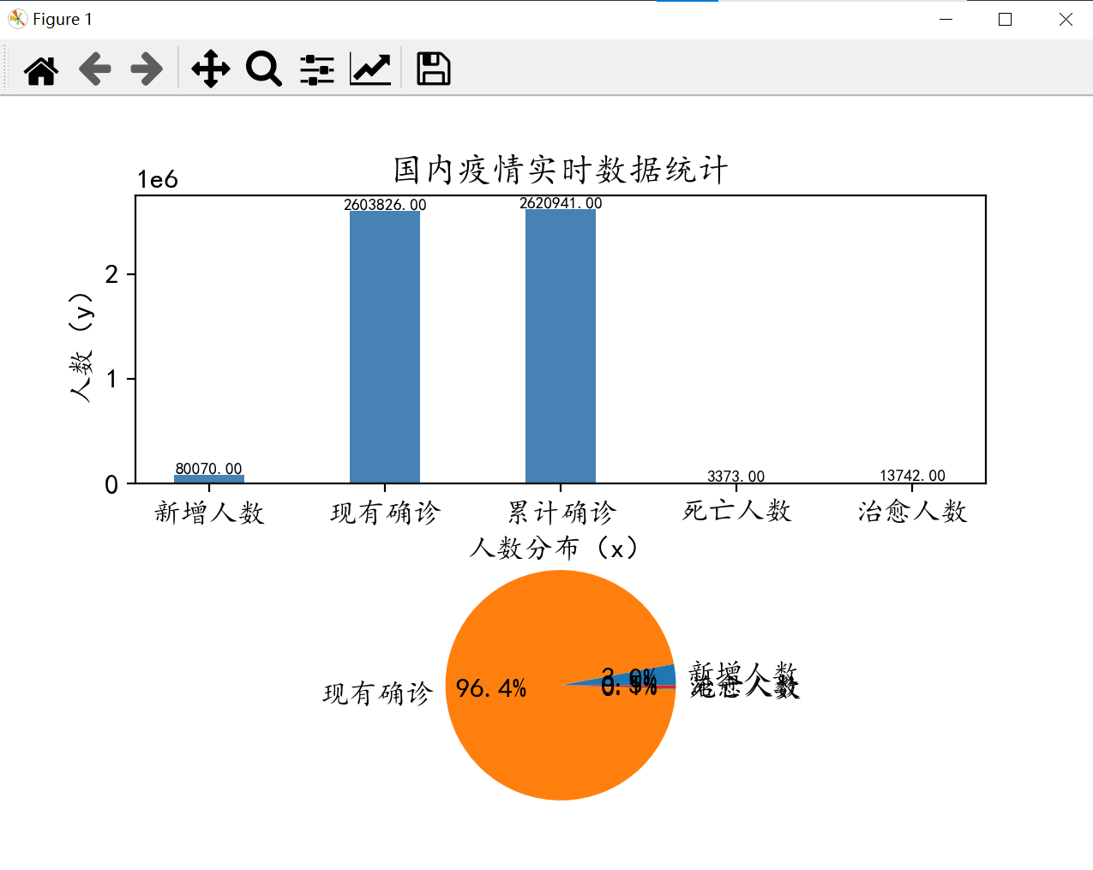
点击生成词云，弹出提示弹窗：
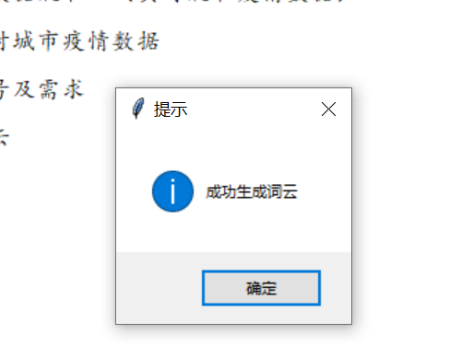
citywordcloud生成疫情省市词云：
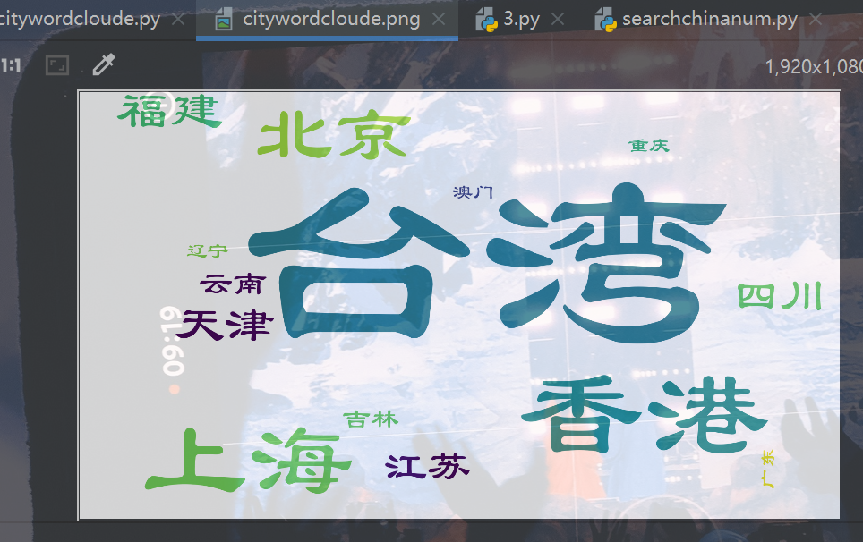

（3）设计心得（不能少于200字)。
在做这个课程设计时，我自学了数据库相关内容，实现了连接数据库实现用户登录，将数据库内容呈现在窗体中。学习了pyqt的安装使用，很大程度上简化了窗体设计过程。学会使用页面跳转，实现点击文字跳转到其他窗体界面。掌握了爬虫技术，爬取全国疫情实时数据，进行数据处理。使用Matplotlib将处理过的数据以图表的形式呈现到窗体。实现了输入不同省市名称，呈现不同省市数据。实现了生成疫情省市词云。在做课程设计的过程中，我将老师教的知识与在各个网站学习的知识结合，期间遇见不少问题，将解决问题的过程记录到个人博客，持续学习并记录。我认为通过这次课程设计的制作，我更深入地学习了python知识，更熟练运用python语言编写程序，十分感谢老师对我的指导。

附：程序代码。
Dao.dao:
import pymysql
conn=pymysql.connect(
host='127.0.0.1',
port=3308,
user='root',
password='root',
charset='utf8',
)
#定义游标对象
cursor=conn.cursor(cursor=pymysql.cursors.DictCursor)
log.welcome:
import sys
from PyQt5.QtWidgets import QApplication, QFrame
# 继承UI文件中的主窗口类
from log import Ui_Frame
class MyMainWindow(QFrame, Ui_Frame):
def __init__(self, parent=None):
super(MyMainWindow, self).__init__(parent)
self.setupUi(self)
if __name__ == "__main__":
app = QApplication(sys.argv)
myWin = MyMainWindow()
myWin.show()
sys.exit(app.exec_())

log.log:
import os
from PyQt5 import QtCore, QtWidgets
from PyQt5.QtWidgets import QDialog
from Dao.dao import cursor
class Ui_Frame(QDialog):
def setupUi(self, Frame):
Frame.setObjectName("1")
Frame.resize(400, 302)
Frame.setFrameShape(QtWidgets.QFrame.StyledPanel)
Frame.setFrameShadow(QtWidgets.QFrame.Raised)
self.tabWidget = QtWidgets.QTabWidget(Frame)
self.tabWidget.setGeometry(QtCore.QRect(70, 30, 281, 231))
self.tabWidget.setObjectName("tabWidget")
self.tab = QtWidgets.QWidget()
self.tab.setObjectName("tab")
self.lineEdit = QtWidgets.QLineEdit(self.tab)
self.lineEdit.setGeometry(QtCore.QRect(120, 50, 113, 25))
self.lineEdit.setObjectName("lineEdit")
self.lineEdit_2 = QtWidgets.QLineEdit(self.tab)
self.lineEdit_2.setGeometry(QtCore.QRect(120, 100, 113, 25))
self.lineEdit_2.setObjectName("lineEdit_2")
self.commandLinkButton = QtWidgets.QCommandLinkButton(self.tab)
self.commandLinkButton.setGeometry(QtCore.QRect(100, 140, 71, 31))
self.commandLinkButton.setObjectName("commandLinkButton")
self.label = QtWidgets.QLabel(self.tab)
self.label.setGeometry(QtCore.QRect(60, 40, 51, 41))
self.label.setObjectName("label")
self.label_2 = QtWidgets.QLabel(self.tab)
self.label_2.setGeometry(QtCore.QRect(60, 80, 51, 61))
self.label_2.setObjectName("label_2")
self.tabWidget.addTab(self.tab, "")
self.tab_2 = QtWidgets.QWidget()
self.tab_2.setObjectName("tab_2")
self.lineEdit_3 = QtWidgets.QLineEdit(self.tab_2)
self.lineEdit_3.setGeometry(QtCore.QRect(120, 50, 113, 25))
self.lineEdit_3.setObjectName("lineEdit_3")
self.lineEdit_4 = QtWidgets.QLineEdit(self.tab_2)
self.lineEdit_4.setGeometry(QtCore.QRect(120, 100, 113, 25))
self.lineEdit_4.setObjectName("lineEdit_4")
self.commandLinkButton_2 = QtWidgets.QCommandLinkButton(self.tab_2)
self.commandLinkButton_2.setGeometry(QtCore.QRect(100, 140, 81, 31))
self.commandLinkButton_2.setObjectName("commandLinkButton_2")
self.label_3 = QtWidgets.QLabel(self.tab_2)
self.label_3.setGeometry(QtCore.QRect(60, 40, 51, 41))
self.label_3.setObjectName("label_3")
self.label_4 = QtWidgets.QLabel(self.tab_2)
self.label_4.setGeometry(QtCore.QRect(60, 80, 61, 61))
self.label_4.setObjectName("label_4")
self.tabWidget.addTab(self.tab_2, "")
self.retranslateUi(Frame)
self.tabWidget.setCurrentIndex(0)
QtCore.QMetaObject.connectSlotsByName(Frame)
def retranslateUi(self, Frame):
global username, password
_translate = QtCore.QCoreApplication.translate
Frame.setWindowTitle(_translate("Frame", "Frame"))
self.commandLinkButton.setText(_translate("Frame", "登录"))
self.label.setText(_translate("Frame", "账号："))
username = self.label.text()
self.label_2.setText(_translate("Frame", "密码："))
password = self.label_2.text()
self.tabWidget.setTabText(self.tabWidget.indexOf(self.tab), _translate("Frame", "Tab 1"))
self.commandLinkButton_2.setText(_translate("Frame", "注册"))
self.label_3.setText(_translate("Frame", "账号："))
self.label_4.setText(_translate("Frame", "密码："))
self.tabWidget.setTabText(self.tabWidget.indexOf(self.tab_2), _translate("Frame", "Tab 2"))
# 按钮绑定事件
self.commandLinkButton.clicked.connect(self.upload)
self.commandLinkButton_2.clicked.connect(self.newuser)
def upload(self):
sql = "select * from user where username=%s and password=%s"
# print(sql)
# 判断是否存在 excute 可以解决sql注入问题
res = cursor.execute(sql, (self.lineEdit.text(), self.lineEdit_2.text()))
res1 = cursor.fetchall()
if res1: # res 或者res1 都可以 返回值
print("登陆成功")
os.system('python mainframewindow.py')
else:
QtWidgets.QMessageBox.question(self, '警告', '账号密码错误，请重新输入', QtWidgets.QMessageBox.Yes)
print('账号或者密码错误')
def newuser(self):
print('2')

log.mainframewindow:
import os
import openpyxl
from ExButton import ExButton, Tk, Canvas, Label
import tkinter.messagebox as msgbox
from PyQt5 import QtCore, QtGui, QtWidgets
import numpy as np
import pandas as pd
import matplotlib
import matplotlib.pyplot as plt
class Main(Tk):
def __init__(self):
super().__init__()
self.top_frame = None
self.button_frame_1 = None
self.button_frame_2 = None
self.main_frame_1 = None
self.main_frame_2 = None
self.top_button_arr = []
self.left_button_arr = []
self.main_button_arr = []
self.initialize()
self.frame_initialize()
self.interface_initialize()
def initialize(self):
self.title("疫情信息管理系统")
self.geometry("1000x620+%d+%d" % (self.winfo_screenwidth() / 2 - 500,
self.winfo_screenheight() / 2 - 390))
# self.resizable(False, False)
def frame_initialize(self):
self.top_frame = Canvas(self, bg="black", height=60, width=1000, highlightthickness=0)
self.top_frame.place(x=0, y=0)
self.button_frame_1 = Canvas(self, bg="White", height=255, width=180, highlightthickness=0)
self.button_frame_1.place(x=30, y=90)
self.button_frame_2 = Canvas(self, bg="White", height=215, width=180, highlightthickness=0)
self.button_frame_2.place(x=30, y=375)
self.main_frame_1 = Canvas(self, bg="White", height=55, width=730, highlightthickness=0)
self.main_frame_1.place(x=240, y=90)
self.main_frame_2 = Canvas(self, bg="White", height=440, width=730, highlightthickness=0)
self.main_frame_2.place(x=240, y=150)
def interface_initialize(self):
# 布置顶层界面
Label(self.top_frame, text="疫情信息管理系统", bg="black", fg="white", font=("楷体", 18)).place(x=30, y=13)
top_button_1 = ExButton(self.top_frame, height=60, width=120, text="退出", font=("楷体", 12),
command=self.loginout)
top_button_1.set(font_color=("White", "White"), color=("Black", "Black"))
top_button_1.place(x=880, y=0)
# 布置按钮界面
Label(self.button_frame_1, text="数据库", bg="white", font=("楷体", 16)).place(x=30, y=10)
left_button = ExButton(self.button_frame_1, height=40, width=180, text="账号信息", font=("楷体", 11),
command=self.show)
left_button.set(button_list=self.left_button_arr, color=("White", "White"),
active_color=("DeepSkyBlue", "#F0F0F0"))
left_button.place(x=0, y=55)
left_button = ExButton(self.button_frame_1, height=40, width=180, text="需求信息", font=("楷体", 11),
command=self.need)
left_button.set(button_list=self.left_button_arr, color=("White", "White"),
active_color=("DeepSkyBlue", "#F0F0F0"))
left_button.place(x=0, y=95)
left_button = ExButton(self.button_frame_1, height=40, width=180, text="获取数据", font=("楷体", 11),
command=self.get)
left_button.set(button_list=self.left_button_arr, color=("White", "White"),
active_color=("DeepSkyBlue", "#F0F0F0"))
left_button.place(x=0, y=135)
left_button = ExButton(self.button_frame_1, height=40, width=180, text="查询城市", font=("楷体", 11),
command=self.check)
left_button.set(button_list=self.left_button_arr, color=("White", "White"),
active_color=("DeepSkyBlue", "#F0F0F0"))
left_button.place(x=0, y=175)
left_button = ExButton(self.button_frame_1, height=40, width=180, text="获取词云", font=("楷体", 11),
command=self.wordcloude)
left_button.set(button_list=self.left_button_arr, color=("White", "White"),
active_color=("DeepSkyBlue", "#F0F0F0"))
left_button.place(x=0, y=215)
# 布置第二层按钮界面
# Label(self.button_frame_2, text="个人中心", bg="white", font=("楷体", 16)).place(x=30, y=10)
# left_button = ExButton(self.button_frame_2, height=40, width=180, text="账号信息", font=("楷体", 11),
# command=self.pass_command)
# left_button.set(button_list=self.left_button_arr, color=("White", "White"),
# active_color=("DeepSkyBlue", "#F0F0F0"))
# left_button.place(x=0, y=55)
# left_button = ExButton(self.button_frame_2, height=40, width=180, text="发布需求", font=("楷体", 11),
# command=self.pass_command)
# left_button.set(button_list=self.left_button_arr, color=("White", "White"),
# active_color=("DeepSkyBlue", "#F0F0F0"))
# left_button.place(x=0, y=95)
# left_button = ExButton(self.button_frame_2, height=40, width=180, text="我的需求", font=("楷体", 11),
# command=self.pass_command)
# left_button.set(button_list=self.left_button_arr, color=("White", "White"),
# active_color=("DeepSkyBlue", "#F0F0F0"))
# left_button.place(x=0, y=135)
# left_button = ExButton(self.button_frame_2, height=40, width=180, text="注销", font=("楷体", 11),
# command=self.pass_command)
# left_button.set(button_list=self.left_button_arr, color=("White", "White"),
# active_color=("DeepSkyBlue", "#F0F0F0"))
# left_button.place(x=0, y=175)
#
# # 页眉
# Label(self.main_frame_1, text="主要功能", bg="White", font=("楷体", 15)).place(x=30, y=13)
#
# # 主界面内容
# main_button = ExButton(self.main_frame_2, text="详情", height=35, width=70, command=self.pass_command,
# font=("楷体", 11), style="vertical_color")
# main_button.set(button_list=self.main_button_arr, active_color=("#F0F0F0", "#F0F0F0"))
# main_button.place(x=0, y=0)
Label(self.main_frame_2, text="Python数据爬取\t（实时爬取疫情数据）", bg="White", font=("楷体", 13)).place(x=25, y=50)
Label(self.main_frame_2, text="查询实时城市疫情数据", bg="White", font=("楷体", 13)).place(x=25, y=85)
Label(self.main_frame_2, text="查看账号及需求", bg="White", font=("楷体", 13)).place(x=25, y=120)
Label(self.main_frame_2, text="查看词云", bg="White", font=("楷体", 13)).place(x=25, y=155)
def pass_command(self):
pass
def loginout(self):
print('退出成功')
exit()
def show(self):
os.system('python ../user.py')
# import user
# self.one = user.tree.selection()()
# self.one.show()
def need(self):
os.system('python ../need.py')
def get(self):
os.system('python ../search/searchchinanum.py')
msgbox.showinfo('提示', '查询成功')
print('查询成功')
def check(self):
# os.system('python ../citydata.py')
global cityname
class Ui_Form(object):
def __init__(self, parent=None):
super(Ui_Form, self).__init__()
# self.setWindowTitle("排列组合")
# self.resize(400, 100)
def setupUi(self, Form):
Form.setObjectName("Form")
Form.resize(463, 362)
self.calendarWidget = QtWidgets.QCalendarWidget(Form)
self.calendarWidget.setGeometry(QtCore.QRect(140, 110, 200, 137))
self.calendarWidget.setObjectName("calendarWidget")
self.buttonBox = QtWidgets.QDialogButtonBox(Form)
self.buttonBox.setGeometry(QtCore.QRect(320, 250, 341, 32))
self.buttonBox.setOrientation(QtCore.Qt.Horizontal)
self.buttonBox.setStandardButtons(QtWidgets.QDialogButtonBox.Cancel | QtWidgets.QDialogButtonBox.Ok)
self.buttonBox.setObjectName("buttonBox")
self.lineEdit = QtWidgets.QLineEdit(Form)
self.lineEdit.setGeometry(QtCore.QRect(172, 70, 141, 21))
self.lineEdit.setObjectName("lineEdit")
self.label = QtWidgets.QLabel(Form)
self.label.setGeometry(QtCore.QRect(190, 40, 111, 21))
self.label.setObjectName("label")
self.pushButton = QtWidgets.QPushButton(Form)
self.pushButton.setGeometry(QtCore.QRect(310, 300, 56, 17))
self.pushButton.setObjectName("pushButton")
self.pushButton_2 = QtWidgets.QPushButton(Form)
self.pushButton_2.setGeometry(QtCore.QRect(380, 300, 56, 17))
self.pushButton_2.setObjectName("pushButton_2")
self.pushButton.clicked.connect(self.search)
self.pushButton_2.clicked.connect(self.exit)
self.retranslateUi(Form)
QtCore.QMetaObject.connectSlotsByName(Form)
def retranslateUi(self, Form):
_translate = QtCore.QCoreApplication.translate
Form.setWindowTitle(_translate("Form", "Form"))
self.label.setText(_translate("Form", "请输入要查询的城市:"))
self.pushButton.setText(_translate("Form", "ok"))
self.pushButton_2.setText(_translate("Form", "exit"))
def search(self):
global cityname
cityname = self.lineEdit.text()
print(cityname)
show()
def exit(self):
print('退出成功')
exit()
def show():
a = cityname
# print(a)
xlsx = pd.read_excel('../data.xlsx', sheet_name='国内疫情实时数据')
xlsx.to_csv('../data.csv', header=None)
new, total, now, dead, heal = np.loadtxt('../data.csv', delimiter=',', usecols=(2, 3, 4, 5, 6), unpack=True,
encoding='utf_8')
# print(new)
# print(total[1])
matplotlib.rcParams['font.family'] = 'Kaiti'
matplotlib.rcParams['font.style'] = 'normal'
matplotlib.rcParams['font.size'] = 12
try:
if a == '台湾':
n = 0
elif a == '香港':
n = 1
elif a == '上海':
n = 2
elif a == '北京':
n = 3
elif a == '四川':
n = 4
elif a == '吉林':
n = 5
elif a == '天津':
n = 6
elif a == '河南':
n = 7
elif a == '福建':
n = 8
elif a == '广东':
n = 9
elif a == '浙江':
n = 10
elif a == '云南':
n = 11
elif a == '江苏':
n = 12
elif a == '广西':
n = 13
elif a == '陕西':
n = 14
elif a == '重庆':
n = 15
elif a == '辽宁':
n = 16
elif a == '青海':
n = 17
elif a == '湖南':
n = 18
elif a == '山东':
n = 19
elif a == '澳门':
n = 20
elif a == '河北':
n = 21
elif a == '山西':
n = 22
elif a == '内蒙古':
n = 23
elif a == '安徽':
n = 24
elif a == '贵州':
n = 25
elif a == '新疆':
n = 26
elif a == '黑龙江':
n = 27
elif a == '海南':
n = 28
elif a == '宁夏':
n = 29
elif a == '湖北':
n = 30
elif a == '江西':
n = 31
elif a == '西藏':
n = 32
elif a == '甘肃':
n = 33
else:
print('请输入正确的省市名称！')
except:
print('请输入正确的省市名称！')
print(n)
plt.subplot(2, 1, 1)
data = [new[n], now[n], total[n], dead[n], heal[n]]
labels = ['新增人数', '现有确诊', '累计确诊', '死亡人数', '治愈人数']
# plt.bar(range(len(data)), data, tick_label=labels)
plt.bar(labels, data, 0.4, color="steelblue")
why = zip(labels, data)
for a, b in why: # 柱子上的数字显示
plt.text(a, b, '%.2f' % b, ha='center', va='bottom', fontsize=7)
plt.title('国内疫情实时数据统计')
plt.xlabel('人数分布（x）')
plt.ylabel('人数（y）')
plt.subplot(2, 1, 2)
labels = '新增人数', '现有确诊', '死亡人数', '治愈人数'
sizes = [new[n], now[n], dead[n], heal[n]]
explode = (0, 0, 0, 0)
plt.pie(sizes, explode=explode, labels=labels, shadow=False, autopct="%1.1f%%")
plt.show()
if __name__ == "__main__":
import sys
app = QtWidgets.QApplication(sys.argv)
widget = QtWidgets.QMainWindow()
ui = Ui_Form()
ui.setupUi(widget)
widget.show()
sys.exit(app.exec_(0))
def wordcloude(self):
# os.system('python ../search/citywordcloude.py')
bg = openpyxl.load_workbook('../data.xlsx')
sheel = bg['国内疫情实时数据']
frequency = {}
for row in sheel.values:
if row[0] == '省份':
pass
else:
frequency[row[0]] = float(row[1])
from wordcloud import WordCloud
wordcloud = WordCloud(font_path="C:/Windows/Fonts/SIMLI.TTF", background_color="white", width=1920, height=1080)
wordcloud.generate_from_frequencies(frequency)
wordcloud.to_file('../citywordcloude.png')
msgbox.showinfo('提示', '成功生成词云')
plt.figure()
plt.imshow(wordcloud, interpolation="bilinear")
plt.axis("off")
plt.show()
print('成功生成词云')
if __name__ == "__main__":
run = Main()
run.mainloop()
search.searchchinanum:
import openpyxl
import requests
send_headers = {
"User-Agent": "Mozilla/5.0 (Windows NT 10.0; Win64; x64; rv:100.0) Gecko/20100101 Firefox/100.0",
"Connection": "keep-alive",
"Accept": "text/html,application/xhtml+xml,application/xml;q=0.9,image/webp,image/apng,*/*;q=0.8",
"Accept-Language": "zh-CN,zh;q=0.8"}
url = 'https://api.inews.qq.com/newsqa/v1/query/inner/publish/modules/list?modules=statisGradeCityDetail,diseaseh5Shelf'
session = requests.session()
response = requests.get(url, verify=False)
json_data = response.json()['data']
china_data = json_data['diseaseh5Shelf']['areaTree'][0]['children'] # 列表
data_set = []
bg = openpyxl.Workbook()
catch = bg.active
catch.title = "国内疫情实时数据"
catch.append(['省份', '新增确诊', '累计确诊', '现有确诊', '累计死亡', '治愈'])
for i in china_data:
data_list = [i['name'], i['today']['confirm'], i['total']['confirm'], i['total']['nowConfirm'], i['total']['dead'],
i['total']['heal']]
for j in range(len(data_list)):
if data_list[j] == '':
data_list[j] = '0'
catch.append(data_list)
bg.save('../data.xlsx')

search.citywordcloude:
import openpyxl
from wordcloud import WordCloud
bg = openpyxl.load_workbook('../data.xlsx')
sheel = bg['国内疫情实时数据']
frequency = {}
for row in sheel.values:
if row[0] == '省份':
pass
else:
frequency[row[0]] = float(row[1])
wordcloud = WordCloud(font_path="C:/Windows/Fonts/SIMLI.TTF",background_color="white",width=1920, height=1080)
wordcloud.generate_from_frequencies(frequency)
wordcloud.to_file('../citywordcloude.png')
malt:
import numpy as np
import pandas as pd
import matplotlib
import matplotlib.pyplot as plt
xlsx = pd.read_excel('data.xlsx', sheet_name='国内疫情实时数据')
xlsx.to_csv('data.csv', header=None)
new, total, now, dead, heal = np.loadtxt('data.csv', delimiter=',', usecols=(2, 3, 4, 5, 6), unpack=True,
encoding='utf_8')
# print(new)
# print(total[1])
matplotlib.rcParams['font.family'] = 'STsong'
matplotlib.rcParams['font.style'] = 'normal'
matplotlib.rcParams['font.size'] = 12
plt.subplot(2, 1, 1)
data = [new[1], now[1], total[1], dead[1], heal[1]]
labels = ['新增人数', '现有确诊', '累计确诊', '死亡人数', '治愈人数']
plt.bar(range(len(data)), data, tick_label=labels)
plt.bar(labels, data, 0.4, color="steelblue")
why = zip(labels, data)
for a, b in why: # 柱子上的数字显示
plt.text(a, b, '%.2f' % b, ha='center', va='bottom', fontsize=7)
plt.title('国内疫情实时数据统计')
plt.xlabel('人数分布（x）')
plt.ylabel('人数（y）')
plt.subplot(2, 1, 2)
labels = '新增人数', '现有确诊', '累计确诊', '死亡人数', '治愈人数'
sizes = [new[1], now[1], total[1], dead[1], heal[1]]
explode = (0, 0, 0, 0, 0)
plt.pie(sizes, explode=explode, labels=labels, shadow=False, autopct="%1.1f%%")
plt.show()

need:
from tkinter import *
from tkinter import ttk
from Dao.dao import conn
cursor = conn.cursor()
# SQL 查询语句
sql = "SELECT * FROM user"
try:
# 执行SQL语句
cursor.execute(sql)
# 获取所有记录列表
results = cursor.fetchall()
for row in results:
fname = row[0]
lname = row[1]
age = row[2]
# 打印结果
# print("fname=%s,lname=%s,age=%s" % \
# (fname, lname, age))
except:
print("Error: 查询数据失败")
root = Tk()
root.title('用户需求')
root.geometry('500x250+380+150')
tree = ttk.Treeview(root, show="headings") # 表格第一列不显示
tree.grid(row=5, columnspan=4)
tree["columns"] = ("#1", "#2", "#3", "#4", "#5")
tree.column("#1", width=100, anchor='center')
tree.column("#2", width=100, anchor='center')
tree.column("#3", width=100, anchor='center')
tree.column("#4", width=100, anchor='center')
tree.column("#5", width=100, anchor='center')
tree.heading("#1", text="用户id")
tree.heading("#2", text="用户名")
tree.heading("#3", text="密码")
tree.heading("#4", text="用户住址")
tree.heading("#5", text="联系方式")
for row in results:
tree.insert("", 0, text="", values=row)
def getItem():
print(tree.selection())
print(tree.item(tree.selection())['row'])
root.mainloop()
user:
from tkinter import *
from tkinter import ttk
from Dao.dao import conn
# 使用cursor()方法获取操作游标
cursor = conn.cursor()
# SQL 查询语句
sql = "SELECT * FROM user"
try:
# 执行SQL语句
cursor.execute(sql)
# 获取所有记录列表
results = cursor.fetchall()
for row in results:
fname = row[0]
lname = row[1]
age = row[2]
# 打印结果
# print("fname=%s,lname=%s,age=%s" % \
# (fname, lname, age))
except:
print("Error: 查询数据失败")
root = Tk()
root.title('用户信息')
root.geometry('500x250+380+150')
tree = ttk.Treeview(root, show="headings") # 表格第一列不显示
tree.grid(row=5, columnspan=4)
tree["columns"] = ("#1", "#2", "#3", "#4", "#5")
tree.column("#1", width=100, anchor='center')
tree.column("#2", width=100, anchor='center')
tree.column("#3", width=100, anchor='center')
tree.column("#4", width=100, anchor='center')
tree.column("#5", width=100, anchor='center')
tree.heading("#1", text="用户id")
tree.heading("#2", text="用户名")
tree.heading("#3", text="密码")
tree.heading("#4", text="用户住址")
tree.heading("#5", text="联系方式")
for row in results:
tree.insert("", 0, text="", values=row)
def getItem():
print(tree.selection())
print(tree.item(tree.selection())['row'])
root.mainloop()

